**2. Data Acquisition and Preparation**

**2.1 Data sources**

Data is scraped from two web pages and also from FourSquare. From [List of postal codes of Canada](https://en.wikipedia.org/wiki/List_of_postal_codes_of_Canada:_M), the postal codes of all the neighbourhoods is extracted and demographics are extracted from [Demographics of Toronto neighbourhoods](https://en.wikipedia.org/wiki/Demographics_of_Toronto_neighbourhoods#:~:text=Etobicoke%20%20%20%20Name%20%20%20,%20%202249%20%2011%20more%20rows)​. Location data is extracted from Geospatial_Coordinates.csv. Venues present in the neighbourhoods are extracted from FourSquare. Dataframes are:

1. df ([List of postal codes of Canada](https://en.wikipedia.org/wiki/List_of_postal_codes_of_Canada:_M))

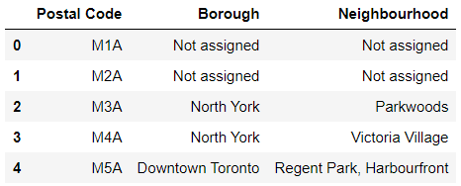

1. ll_data (Geospatial_Coordinates.csv)

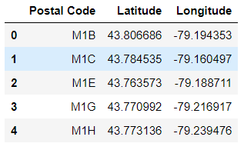

1. pop_den ([Demographics of Toronto neighbourhoods](https://en.wikipedia.org/wiki/Demographics_of_Toronto_neighbourhoods#:~:text=Etobicoke%20%20%20%20Name%20%20%20,%20%202249%20%2011%20more%20rows)​)

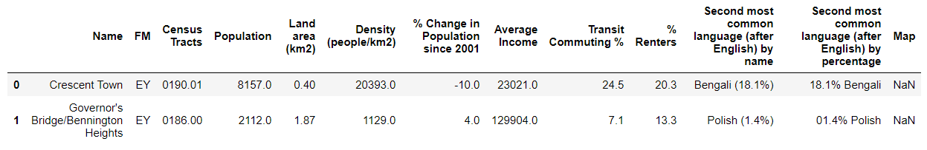

1. neigh_venues (FourSquare API)

